**News Release**

**Digitalization in Aerospace: Oerlikon and MTU Aero Engines initiate establishment of a smart thermal spray factory**

Wohlen, Switzerland / Farnborough, UK - July 23, 2024 – **At the Farnborough International Airshow 2024, Oerlikon and MTU Aero Engines have agreed on the next phase of the collaboration agreement signed at Paris Airshow 2023 to establish a smart and standardized thermal spray factory of the future. By leveraging this cutting-edge technology and integrating digital processes, the companies aim to achieve an unprecedented level of productivity, efficiency, quality and transparency throughout the entire production chain of aerospace components.**

One important key element is achieving 100% digital traceability on the part level through the implementation of advanced measures by tracking every part throughout the production process, ensuring complete transparency and accountability. Another crucial component is the creation of a digital twin, simulating the production of aerospace components to enable real-time monitoring, analysis, and optimization. Additionally, the project will incorporate health, safety, and sustainability initiatives, focusing on reducing environmental impact through improved energy efficiency and waste reduction.

To address the complexity of the project tasks and ensure seamless integration of systems and processes, Oerlikon and MTU will establish a cross-functional project team. Both companies have affirmed their commitment to innovation and change, challenging traditional practices and pushing boundaries to drive continuous improvement and optimization.

The project will comprise distinct phases and deliverables, including system connectivity, bi-directional system integration, structured data mapping and architecture, data screening for anomaly detection using data science, and process adaptation featuring automatic improvement proposals, predictive maintenance, and process optimization.

"We are excited to partner with Oerlikon to establish a state-of-the-art thermal spray factory," says Markus Zeis, SVP Enablement at MTU Aero Engines. "This initiative represents a major step forward in our efforts to enhance efficiency, quality, and sustainability using thermal spray production."

Toby Middlemiss, Head of Aerospace at Oerlikon, says: "Collaborating with MTU Aero Engines on this project is a testament to our shared commitment to innovation, excellence and digitalization. We look forward to leveraging our expertise and resources to create a smart factory that sets new standards in production processes of the aerospace industry."

Visitors at the Farnborough International Airshow are welcome to receive more information about this collaboration at Booth 3540 in Hall 3.

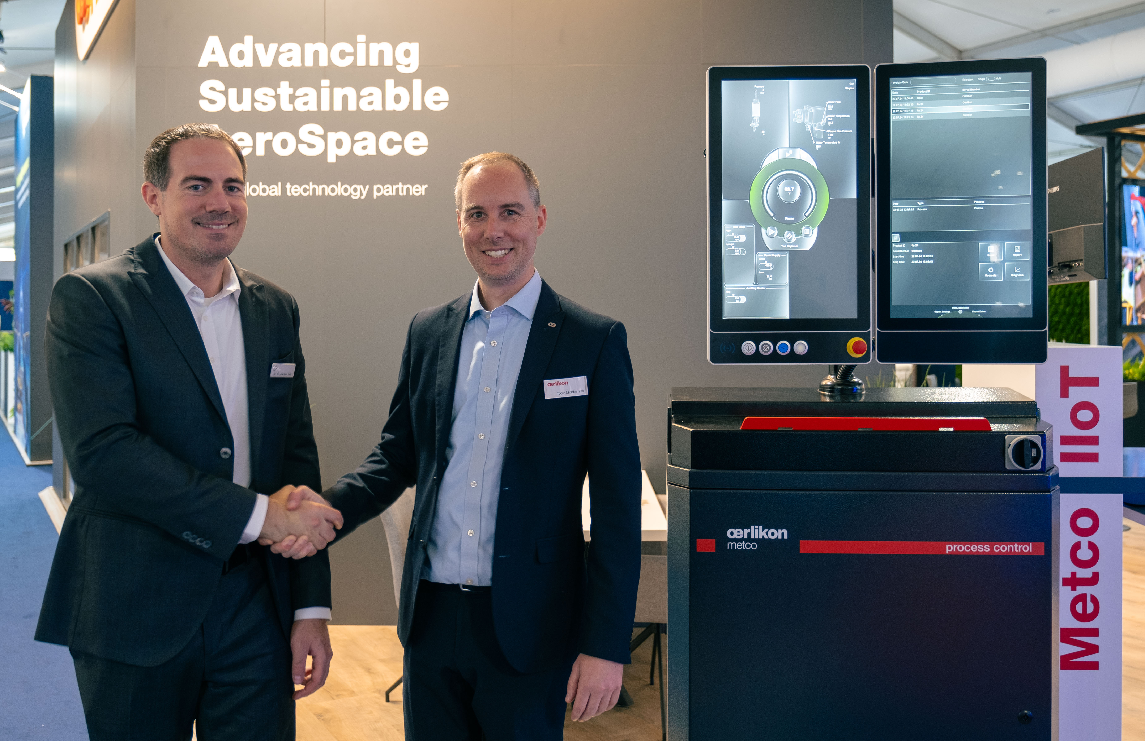

At the Farnborough International Airshow 2024, Toby Middlemiss (Head of Aerospace at Oerlikon) and Dr. Markus Zeis (SVP Enablement at MTU Aero Engines) shake hands on the next phase of their collaboration agreement to establish a smart thermal spray factory, marking a significant step towards digitalization in aerospace.

**For further information, please contact:**

|  |  |  |
| --- | --- | --- |
| **Oerlikon** Petra Ammann  Head of Marketing Communications  Oerlikon Surface Solutions  T +423 388 7500  petra.ammann@oerlikon.com  [http://www.oerlikon.com/](http://www.oerlikon.com/balzers) | **MTU Aero Engines** MartinaVollmuth Press Officer Technology  MTU Aero Engines  T: +49 176 1001 7133 [martina.vollmuth@mtu.de](mailto:martina.vollmuth@mtu.de)  [www.mtu.de](https://eur01.safelinks.protection.outlook.com/?url=http%3A%2F%2Fwww.mtu.de%2F&data=05%7C02%7CAnja.Goller%40oerlikon.com%7C56841d083848497b47f908dc5d3efd5e%7C5358c2a8c6ed4ce99d04202a74f90369%7C0%7C0%7C638487772367585448%7CUnknown%7CTWFpbGZsb3d8eyJWIjoiMC4wLjAwMDAiLCJQIjoiV2luMzIiLCJBTiI6Ik1haWwiLCJXVCI6Mn0%3D%7C0%7C%7C%7C&sdata=JHElvzz8k75EVH4ggWL0xurFk5%2FiX0Vyu5mp03q1IPY%3D&reserved=0) |  |

**About the Oerlikon Surface Solutions Division**

Oerlikon is a leading global provider of surface and additive manufacturing solutions and services. The division offers an extensive portfolio of market-leading thin-film, thermal spray and additive manufacturing technologies, equipment, components and materials. Emission reduction in transportation, maximized longevity and performance of tools and components, increased efficiency and intelligent materials are hallmarks of its leadership. Pioneering technology for decades, the division serves customers with standardized and customized solutions across a worldwide network of more than 170 sites in 37 countries.

With its technology brands – Oerlikon Balzers, Oerlikon Metco and Oerlikon AM – the Oerlikon Surface Solutions division focuses on technologies and services that improve and maximize performance, function, design, reliability and sustainability, which are innovative, game-changing advantages for customers in the automotive, aviation, tooling and general industries and in the luxury, medical, semiconductors, power generation and oil & gas markets.

The division is part of the publicly listed Oerlikon Group (SIX: OERL), headquartered in Switzerland, which has more than 12 600 employees and generated CHF 2.7 billion in revenue in 2023.  
For more information see: www.oerlikon.com/surface-solutions

**About MTU Aero Engines**

MTU Aero Engines AG is Germany’s leading engine manufacturer. The company is a technological leader in low-pressure turbines, high-pressure compressors, turbine center frames as well as manufacturing processes and repair techniques. In the commercial OEM business, the company plays a key role in the development, manufacturing and marketing of high-tech components together with international partners.   
  
Some 30 percent of today’s active aircraft in service worldwide have MTU components on board. In the commercial maintenance sector, the company ranks among the top 3 service providers for commercial aircraft engines and industrial gas turbines. The activities are combined under the roof of MTU Maintenance. In the military arena, MTU Aero Engines is Germany's industrial lead company for practically all engines operated by the country’s military. MTU operates a network of locations around the globe; Munich is home to its corporate headquarters.   
  
In fiscal 2023, the company had a workforce of more than 12,000 employees and posted consolidated sales of 6.3 billion euros.  
For more information see: https://www.mtu.de/